**\Visual Programming Tutorial Questions**

1. Write a console program that sum the elements of array A and output their sum and average.



1. Explain an implicitly typed variable in C#.
2. Write a Timestable program which does the following:

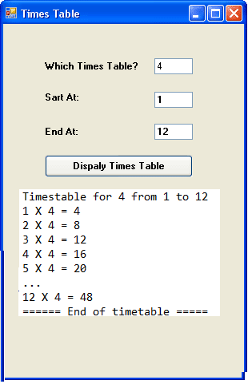

1. Allow the user to input the following variables through text boxes
   * any number num
   * starting number start_num
   * end number end_num
2. Use any appropriate loop to multiply num with numbers from start_num to end_num and display the computations in a list box as shown on the fig above.
3. The program should display:
   * The opening statement as shown in the fig above
   * The closing statement
4. What do you understand by Narrowing conversion? Give an example
5. Write a C# console program that converts a mile into its equivalent metric kilometre measurement (1 mile = 1.6km). Performing a compile-time initialization of 10 for the miles value. The program must display the original miles and the formatted converted value.
6. Explain the difference between passing by reference and passing by value with the aid of an example.
7. Define exception handling with the aid of an example. Your example must illustrate the use of all the blocks used in exception handling.
8. State and explain the major components of the .NET Framework.
9. Design a loan management application that computes the interest paid over the life time of loan. The interface of the application should allow the user to enter the loan amount, interest rate and number of years for a particular loan.

***Interest*** *= (loan amount * Rate * Time)*

The application should then be able to;

1. Determine the monthly instalment,
2. Calculate how much interest will be paid over the life of a loan
3. Display a table showing the new balance after each payment is made.

Note: More marks will be awarded for the use of appropriate controls on the interface and validations.

1. Write a method called **my_sum** that accepts two integers as parameters and returns the sum of the two numbers. Demonstrate how you can call it from the main method.
2. Write code that connects to a MS SQL Server database named **HIT** which resides on a server called **HITProjects**. Assume the user is **admin** and the password **“123”.** Connection timeout is 5 seconds.
3. Differentiate DataReader from DataSet giving code examples with respect to a specific database vendor of your choice.
4. Using database in 5b, assume the database has a table named projects. Write a program that will retrieve all the project records and populate a dataGridView.
5. Given the following program segment, answer questions a through c.

public class Employee

{

private int empNumber;

private decimal pay;

}

1. Define a read-only property for the pay data member.
2. Define a default constructor for Employee.
3. Define a more useful constructor that could be used to instantiate objects of the class.
4. Differentiate ref and out parameters with the aid of examples.
5. What do you understand by implicitly typed variable?